David Baulcombe – curriculum vitae

Dept. Plant Sciences, University of Cambridge, Downing Street, Cambridge CB2 3EA
phone: (44)(0) 1223 339386
fax: (44)(0) 1223 339953
email: dcb40@cam.ac.uk
website: www.plantsci.cam.ac.uk/research/davidbaulcombe.html

Personal
Married to Rose Eden since 1976 with four children: Harriet, Ralph, Cecily and Martha

Education and Career
1970 – 1973 University of Leeds B.Sc (I) - Botany
1973 – 1977 University of Edinburgh Ph.D - Botany

1977 – 1978 McGill University, Montreal, Canada; Post-doctoral Fellow
1978 – 1980 University of Georgia, Athens, GA; Post-doctoral Fellow
1980 – 1988 Plant Breeding Institute, Cambridge, UK; Higher and Principal Scientific Officer
1988 – 2007 Sainsbury Laboratory, Norwich, UK; Senior Research Scientist and Head of Laboratory (from 1990 – 1993 and 1999 – 2003),
2002 – 2007 University of East Anglia; Professor
2007– 2022 University of Cambridge, Cambridge UK; Regius Professor of Botany (2007 – 2019 and then Emeritus), Royal Society Edward Penley Abraham Research Professor (2007-2022) and Head of the Department of Plant Sciences (2009 - 2017).

Professional Memberships
Society for Experimental Biology, Society for General Microbiology, Biochemical Society, Genetics Society, Royal Society, National Academy of Sciences USA

Honours and Awards
- Major Awards and recognition
Gruber Genetics Prize (2014) Gruber Foundation USA (shared with Ambros and Ruvkun)
Balzan Prize (2012) (for epigenetics) Balzan Foundation, Rome
Wolf Prize for Agriculture (2010) Wolf Foundation Israel
Knight Bachelor, (Queens Birthday Honours list 2009)
Albert Lasker Award for Basic Medical Research (2008) Lasker Foundation (shared with Ambros and Ruvkun)
Royal Medal (2006) The Royal Society
Foreign Associate Member of the National Academy of Sciences (USA) (elected 2005)
Fellow of the Royal Society (elected 2001)
- Awards
Sir Hans Krebs Medal and Lecture (2021) Federation of European Biochemical Societies
Mendel Medal (2017) Genetics Society
Prize Medal Lecture (2015) Society for General Microbiology
The McClintock Prize for Plant Genetics and Genome Studies (2014) Maize Genetics Executive Committee;
Harvey Prize in Science and Technology (2009) Technion Israel Institute of Technology
Benjamin Franklin Medal in Life Science (2008) Franklin Institute, Philadelphia (joint with Ambros and Ruvkun)
Special Achievement Award (2008) Miami Winter Symposium
Massry Prize (2005) Massry Foundation – University of Southern California (shared with Fire and Mello)
M.W. Beijerinck Virology Prize (2004) Royal Netherlands Academy of Arts and Sciences
Wiley Prize in Biomedical Science (2003) (Wiley Foundation – Rockefeller University - shared with Fire, Mello and Tuschl)
Ruth Allen Award, American Phytopathology Society (2002)
Kumho Science International Award in Plant Molecular Biology and Biotechnology (2002) Kumho Cultural Foundation, Korea
Prix des Cerealiers de France (1990) for work on hormonally regulated genes of cereals
- Elected Fellowships
Lifetime Member of the Pontifical Academy of Sciences (2020)
Honorary Fellow (2020) Cambridge Philosophical Society
Honorary Fellow of the Royal Society of Edinburgh (elected 2015)
Corresponding Member (2013) Royal Academy of Arts and Sciences Barcelona
Foreign Fellow (2011) National Academy of Science, India
Fellow of the Academy of Medical Sciences (elected 2010)
Fellow, Trinity College Cambridge (elected 2009-2019 then Emeritus)
Honorary Professor, University of East Anglia (1998-2002)
Academia Europaea, Member (elected 2002)
European Molecular Biology Organisation, Member (elected 1997)
- Academic Societies
President Biochemical Society (Jan 2015 – December 2017)
President International Society for Plant Molecular Biology (2003 – 2006)
- Honorary Degrees
DSc (Hon) University of Leeds (2015)
Honorary Doctorate University of Helsinki (2014)
DSc (Hon) Edinburgh (2014)
DL (Hon) Dundee (2014)
DSc (Hon) University of East Anglia (2011)
DSc (Hon) University of Birmingham (2011)
Honorary Doctorate Wageningen Agricultural University (2008)

Current and Recent Community Service
Lawes Agricultural Trustee (2009-)
Rothamsted Research – Trustee Board Member (2012-)
Biochemical Society President (2015-7 );
Biotechnology and Biological Sciences Research Council (Member, 2009-2016)
Boyce Thompson Institute, Cornell, Science Advisory Board (2015-18)
Sainsbury Laboratory Cambridge (Management Board, Chair) (2010-6)
Institute of Plant and Microbial Biology Academia Sinica, Taipei, Taiwan (2018 -)

Current research interests
Since 1973, when I started my research career, I have thought that one of the major challenges in biology is understanding of gene regulation in plants and animals. Genes are switched on and off during development and in response to the environment so that biology at molecular, organismal and population levels would be informed by knowledge about gene regulation. It has been the underlying theme throughout my research career. I work on plants but the general concepts and many of the mechanisms are common to all parts of the tree of life and my work has had impact in diverse areas including agriculture and biomedicine.

To begin with I focused on individual genes but advanced technology and computing now allows analysis of complex gene networks. This embracing of complexity means that molecular biology has moved beyond the phase of ‘stamp collecting’: the naming of parts in a cell. We can now begin to address the question of emergent properties in which cells and organisms are more than the simple sum of their parts so that molecular biology is truly ‘biology’. My group has become interested in epigenetics – the science of how nurture influences nature - and how environmental effects can be transmitted from one generation to the next.

Outside the laboratory I promote the use of plant biotechnology for crop improvement. I raised funds to endow a Professor of Crop Science and to support a new Crop Science Research Laboratory for the University of Cambridge. I am particularly interested in addressing developing country problems and in reducing the environmental impact of crops everywhere. A particular challenge is to ensure equitable use of new technology as part of a holistic assessment of agriculture and food production systems.

Dal 1973, anno in cui ho iniziato la mia carriera di ricercatore, ho pensato che una delle maggiori sfide in biologia fosse la comprensione della regolazione genica nelle piante e negli animali. I geni vengono attivati ​​e disattivati ​​durante lo sviluppo e in risposta all'ambiente in modo che la biologia a livello molecolare, organico e della popolazione possa essere informata dalla conoscenza della regolazione genica. È stato il filo conduttore di tutta la mia carriera di ricerca. Lavoro sulle piante ma i concetti generali e molti dei meccanismi sono comuni a tutte le parti dell'albero della vita e il mio lavoro ha avuto un impatto in diverse aree, tra cui l'agricoltura e la biomedicina.

All'inizio mi sono concentrato sui singoli geni, ma la tecnologia avanzata e l'informatica ora consentono l'analisi di reti di geni complessi. Questa comprensione della complessità significa che la biologia molecolare è andata oltre la fase di "raccolta di francobolli": la denominazione di parti in una cellula. Possiamo ora iniziare ad affrontare la questione delle proprietà emergenti in cui le cellule e gli organismi sono più della semplice somma delle loro parti, in modo che la biologia molecolare sia veramente "biologia". Il mio gruppo si è interessato all'epigenetica - la scienza di come il nutrimento influenza la natura - e al modo in cui gli effetti ambientali possono essere trasmessi da una generazione all'altra.

All'esterno del laboratorio promuovo l'utilizzo delle biotecnologie vegetali per il miglioramento delle colture. Ho raccolto fondi per dotare un professore di scienza delle colture e per sostenere un nuovo laboratorio di ricerca sulla scienza delle colture per l'Università di Cambridge. Sono particolarmente interessato ad affrontare i problemi dei paesi in via di sviluppo e a ridurre l'impatto ambientale dei raccolti ovunque. Una sfida particolare è garantire un uso equo delle nuove tecnologie come parte di una valutazione olistica dell'agricoltura e del sistema di produzione alimentare.

Current and recent research funding
*ERC-2008-Advanced Investigator Grant (233325) ‘REVOLUTION’ 1-3-2009 28-12-2013 (RNA mediated regulation in growth, development and evolution (E2.3M)
*Royal Society Research Professorship: September 2007 – September 2022 (salary + £90K research expense pa from 2017 (£16K until 2017)
*ERC 2013-Advanced Investigator Grant (340642) ‘TRIBE’ (Transgressive phenotypes in breeding and evolution) 1-3-2014 28-2-2019 (E2.4M)
*Syngenta – Analysis of Heterosis in Tomato (undisclosed amount – 2 researchers + expenses FEC) 1-1-14 to 30-6-16
^{c}BBSRC–EPSRC BB/LO1413 OpenPlant £12M Synthetic biology grant with JIC – Baulcombe and Sanders PIs
*BBSRC BB/P020321/1 – ‘Molecular dissection of paramutation in tomato’ 1-10-17 to 30-09-20 (£665K)
*BBSRC BB//R018529/1 - An RNA cascade and disease resistance in tomato 1-1-19 to 31-12-21 (£645K)
*BBSRC BB/T013117/1- Epigenetics and hidden heritability in tomato1-1-21 to 31-12-24 (£732K)

* PI ^{c} Co I

Key Publications

1. Shivaprasad, P. V., Dunn, R. ., Santos, B. A. C. M., Bassett, A. & Baulcombe, D. C. Extraordinary transgressive phenotypes of hybrid tomato are influenced by epigenetics and small silencing RNAs. EMBO J. 31, 257–66 (2012).
2. Shivaprasad, P. V. et al. A microRNA superfamily regulates nucleotide binding site-leucine-rich repeats and other mRNAs. Plant Cell 24, 859–74 (2012).
3. Pretty, J. et al. The top 100 questions of importance to the future of global agriculture. Int. J. Agric. Sustain. 8, (2010).
4. Mosher, R. A. et al. Uniparental expression of PolIV-dependent siRNAs in developing endosperm of Arabidopsis. Nature 460, 283-U151 (2009).
5. Molnar, A. et al. Small Silencing RNAs in Plants Are Mobile and Direct Epigenetic Modification in Recipient Cells. Science (80-. ). 328, 872–875 (2010).
6. Herr, A. J., Jensen, M. B., Dalmay, T. & Baulcombe, D. C. RNA polymerase IV directs silencing of endogenous DNA. Science (80-. ). 308, 118–120 (2005).
7. Baulcombe, D. RNA silencing in plants. Nature 431, 356–363 (2004).
8. Dalmay, T., Hamilton, A. J., Rudd, S., Angell, S. & Baulcombe, D. C. An RNA-dependent RNA polymerase gene in Arabidopsis is required for posttranscriptional gene silencing mediated by a transgene but not by a virus. Cell 101, 543–553 (2000).
9. Voinnet, O., Pinto, Y. M. M. & Baulcombe, D. C. C. Suppression of gene silencing: a general strategy used by diverse DNA and RNA viruses of plants. Proc. Natl. Acad. Sci. U. S. A. 96, 14147–52 (1999).
10. Hamilton, A. J. & Baulcombe, D. C. A species of small antisense RNA in posttranscriptional gene silencing in plants. Science (80-. ). 286, 950–952 (1999).
11. Ratcliff, F., Harrison, B. D. & Baulcombe, D. C. A similarity between viral defense and gene silencing in plants. Science (80-. ). 276, 1558–1560 (1997).
12. Li, H. et al. Induction and Suppression of RNA Silencing by an Animal Virus. Science (80-. ). 296, 1319–21 (2002).
13. Baulcombe, D. C. RNA as a target and an initiator of post-transcriptional gene silencing in transgenic plants. Plant Mol. Biol. 32, 79–88 (1996).
14. Harrison, B. B. D., Mayo, M. M. A. & Baulcombe, D. C. D. Virus resistance in transgenic plants that express cucumber mosaic virus satellite RNA. Nature 328, 799–802 (1987).

https://scholar.google.co.uk/citations?user=NPrjUiYAAAAJ

Web of Science Profile

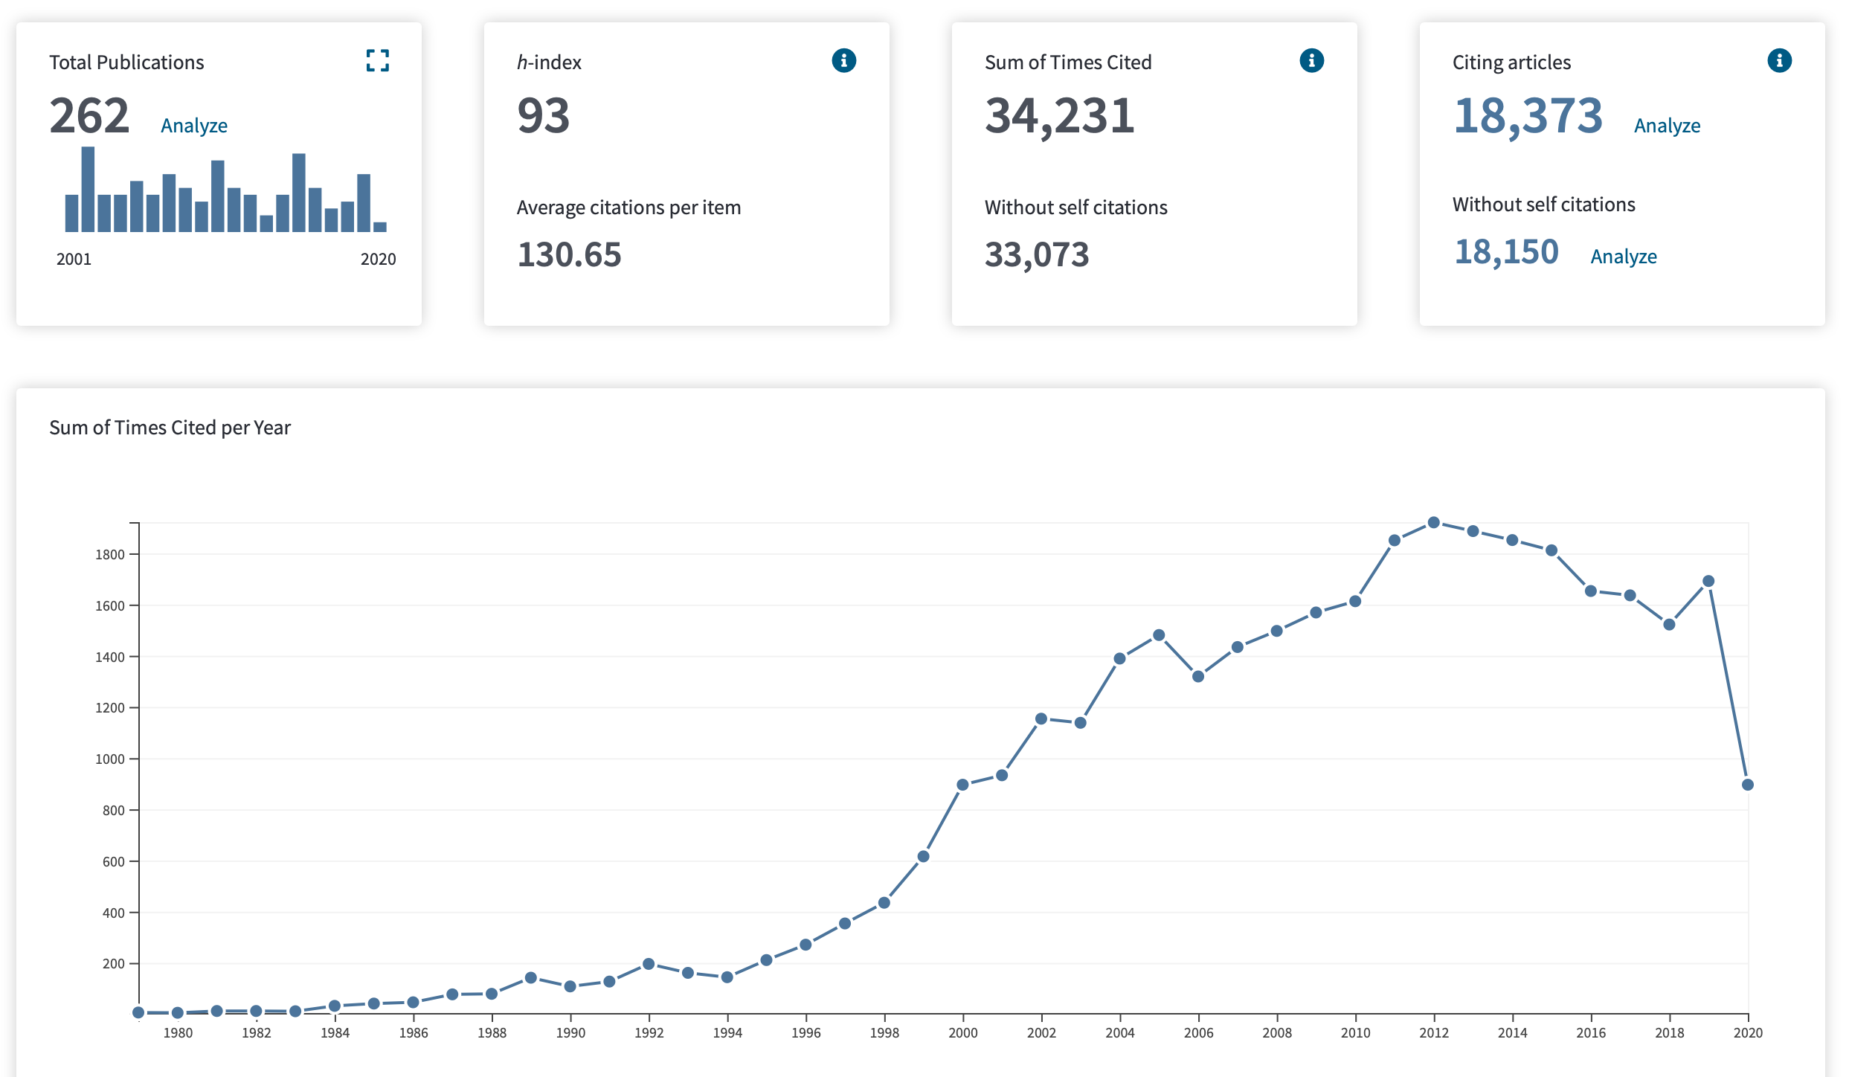

September 2020

